Assignment-Digital Marketing

|  |  |
| --- | --- |
| Name | SIVA ARUNACHALAM |
| RegNo | 962820106032 |
| NM ID | 74F5CAF089B77ADA4EC43AF034B5BE7E |

Blog link:<https://springlearner9.wordpress.com/>

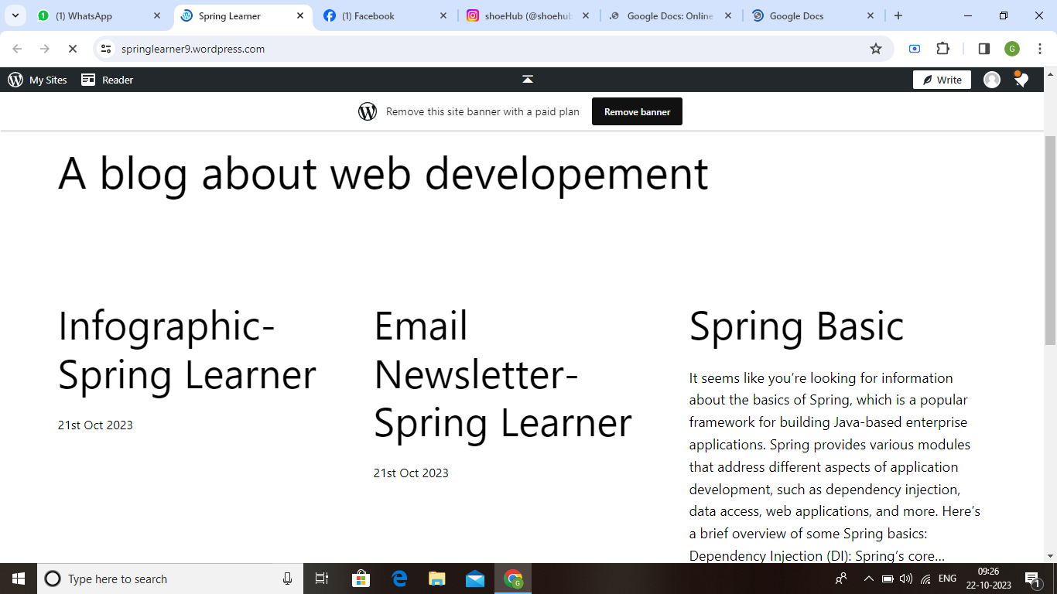

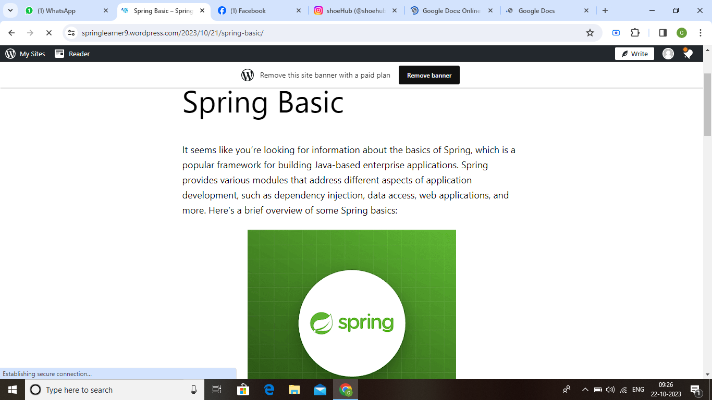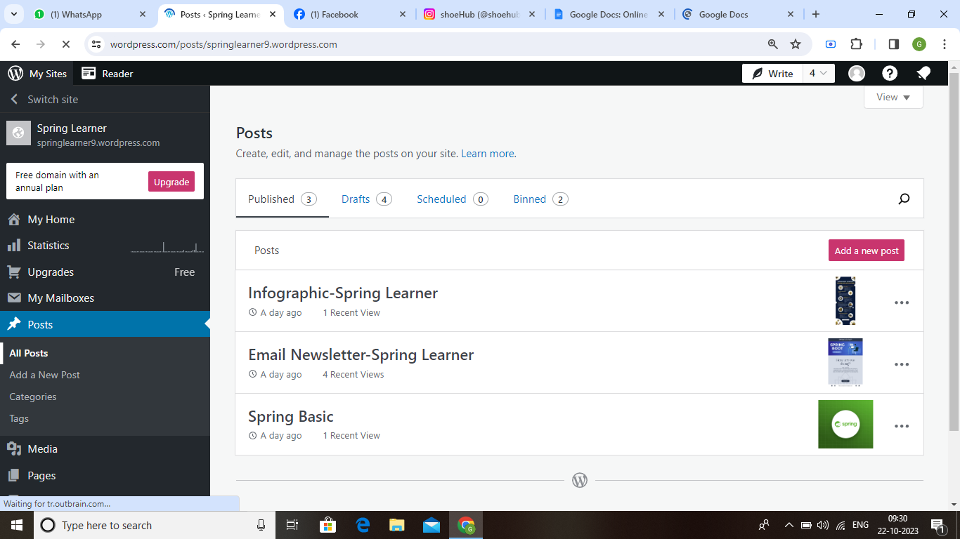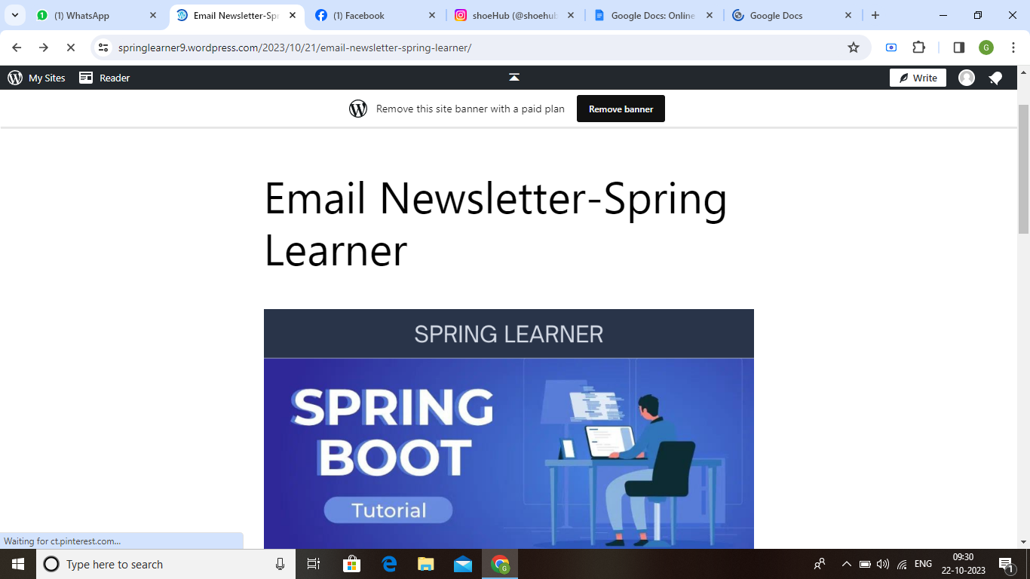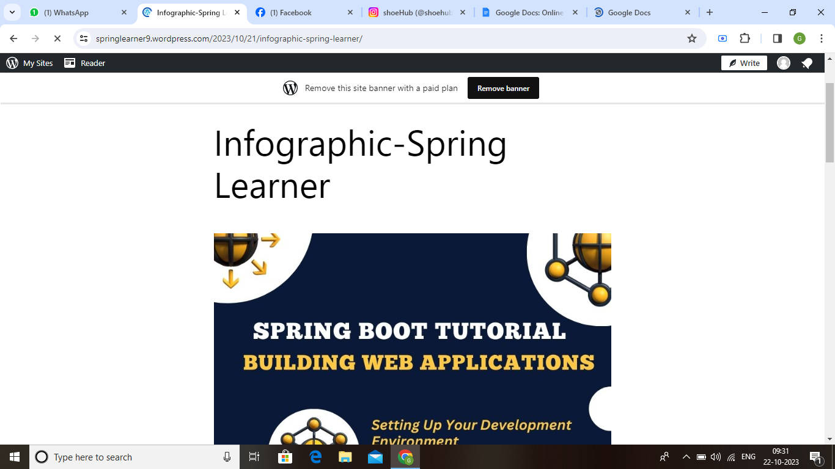

FB page link:<https://www.facebook.com/SpringLearner>

